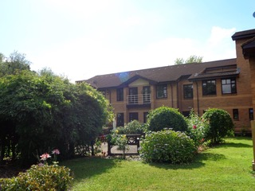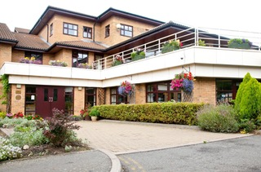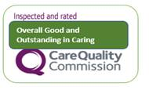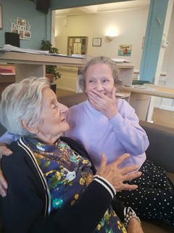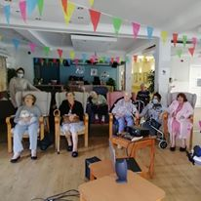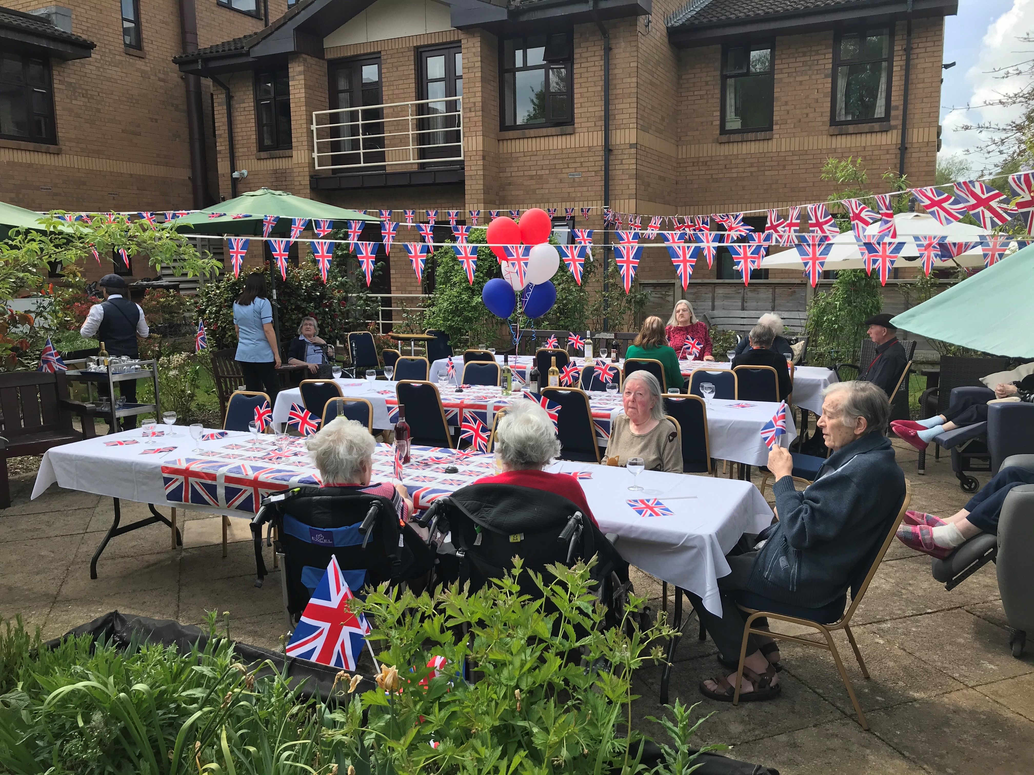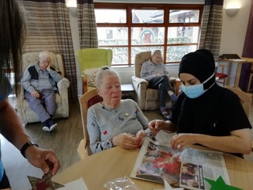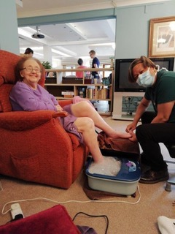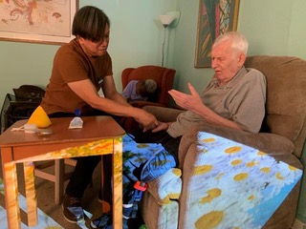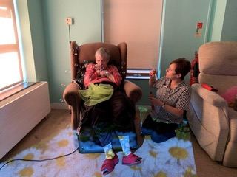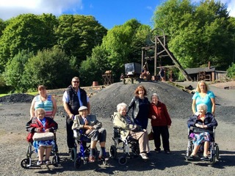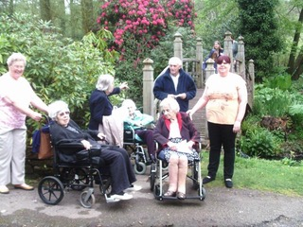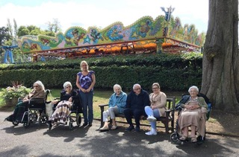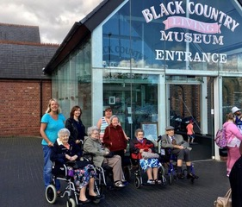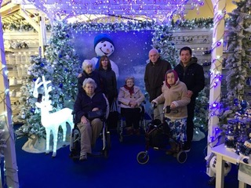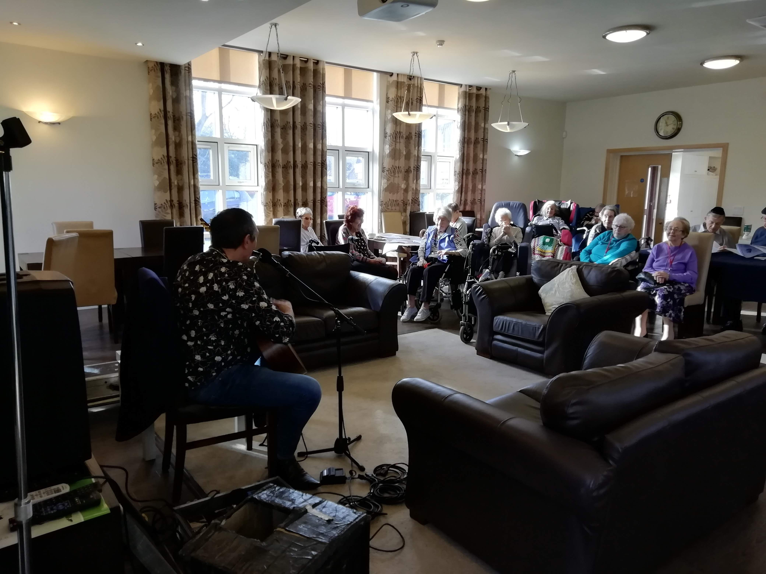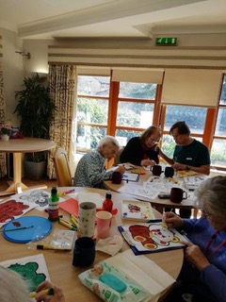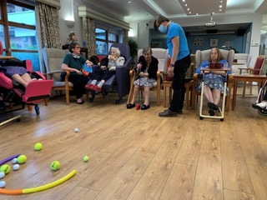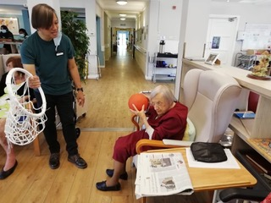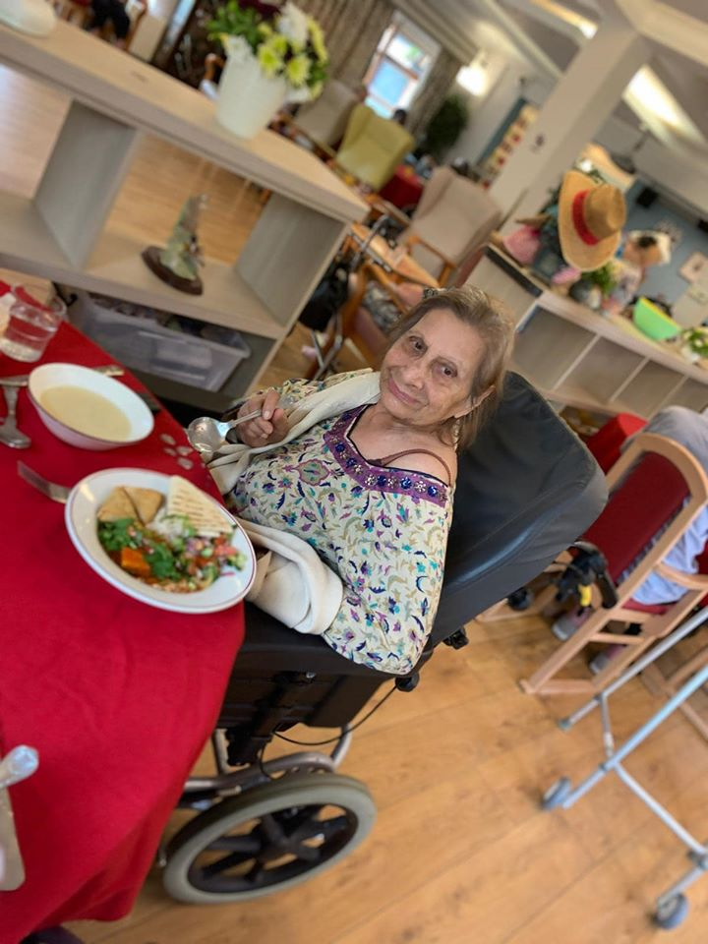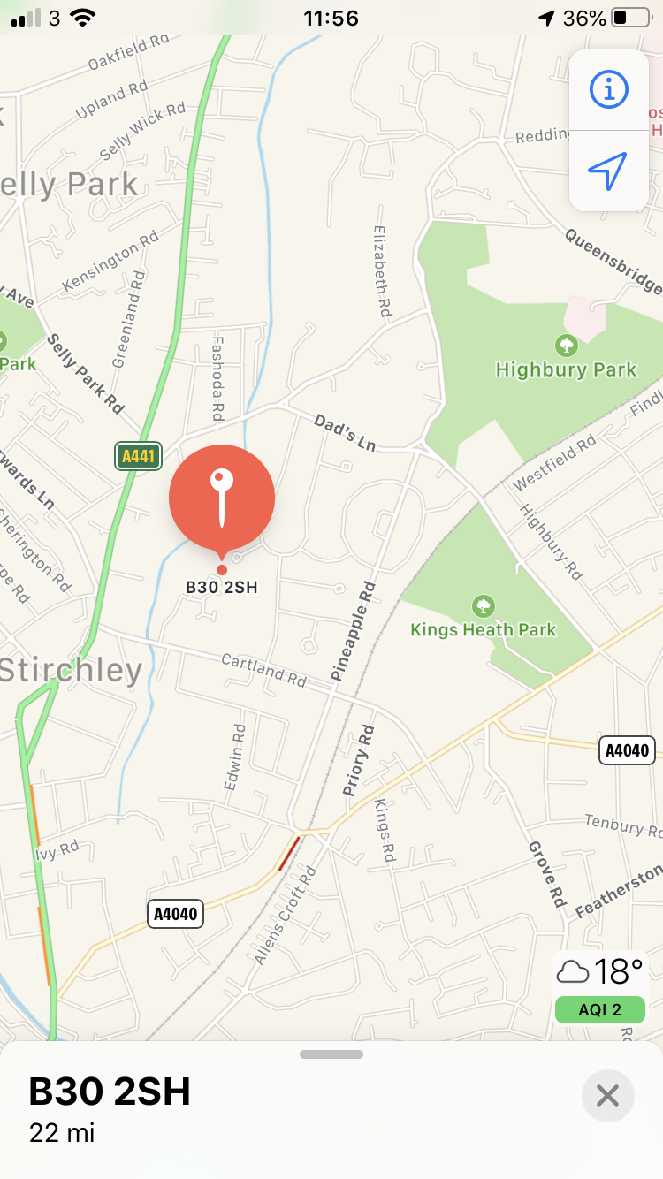

ANDREW COHEN HOUSE

BIRMINGHAM JEWISH COMMUNITY CARE

Quality Nursing and Residential Care

Andrew Cohen House is a purpose built registered care home and was officially opened by HRH, Princess Diana in 1993.

The home has 51 rooms with en-suite facilities on 2 floors and an 8 bed household for those needing the greatest level of care. There are adjoining rooms which are suitable for couples. All rooms have views of the landscaped gardens where residents can relax.

Andrew Cohen House is run as a Jewish Home and we offer a menu of kosher food for residents. We welcome people of all faiths and none.

The Home provides very high standard of nursing and residential care under the supervision of the Home Manager and her dedicated staff. We also offer short-term stays for respite and convalescence.

Welcome to your new home

e to your new home

**Residential** – We will provide you with 24 hour personal care by experienced and competent carers.

**Nursing** - We offer 24 hour nursing care by a professional team of highly skilled nurses and carers.

**Respite** – Short term stays and care can be arranged. It can be anything from a few days to a few weeks. There are regular visits by a chiropodist, optician and dentist. A GP holds a weekly surgery and is also available out of hours.

**Residents Charter** – ACH is committed to ensuring that your rights are respected at all times and to provide you with the very highest standards of care in quality surroundings.

**Privacy** – your room is personal and private and you have the right to not be disturbed if you wish. Staff will always knock before entering.

**Choice** – It is your choice what you do each day – when to get up in the morning, what to eat, where to eat, what activities you wish to take part in and when to go to bed. We will agree with you and your relatives every aspect of your care plan.

**Dignity** – We believe strongly that each person has individual needs and the right to decide what happens to them.

Caring for You

At Andrew Cohen House, we understand that it can be difficult leaving your own home and we will ensure that every effort is made to make you feel welcome in your new Home.

We have a strong management team led by our Home Manager who is supported by a team of trained Nurses. Between them they have many years of nursing experience in palliative care and care for the elderly.

There are regular meetings for relatives and friends of our residents at which they can raise any general questions. There is a well documented procedure should a relative or visitor wish to raise a query of complaint.

We have our own Administrations staff and our Housekeeping Team ensure the Home maintains its high standards of cleanliness.

A daily programme of varied activities is arranged for residents and everyone will be able to find something of interest.

The Rabbi is always available to give spiritual advice and is also responsible for ensuring that any new members of staff are aware of the ethos of a Jewish Home and the aspects of the different Jewish festivals.

We have our own Social Care Team, who give advice and liaise with Social Services and other agencies that offer support with moving to residential care.

Who cares for you?

Trips are organised regularly to get the residents out and about enjoying different activites and being outside in the fresh air. These include trips to garden centres, Black Country Museum and visits to the local parks.

Trips and Events

All activities are planned to take into account the residents interests and circumstances, and are designed to help mobility and to take a positive interest in life. Games such as cards, bingo, scrabble, draughts and quizzes are available. Armchair exercise to music which helps mobility, is a favourite amongst residents. A variety of entertainers visit the home.

Andrew Cohen House is run as a traditional Jewish Home and includes all levels of belief and practice so that residents can choose how and if they wish to take part.

Services are held in the synagogue every Friday evening and Sabbath as well as all Jewish festivals. Relatives and friends are welcome to attend. Passover sender meals are held on both nights for residents and their relatives and all festivals are celebrated with traditional foods. On the anniversary of the Yahrzeit, candles can be lit and Kaddish recited for those who have requested. A strictly kosher menu is provided offering a balanced diet and this can be varied to take into account any medical requirements.

Religion and Activities

We understand how important meal times are to our residents and we provide high quality, varied nutritious food.

All meals are prepared in our own kitchens by experienced chefs, with kosher supervision by our own Rabbi.

Tea, coffee and other hot drinks and snacks are available 24 hours a day and whilst residents are encouraged to eat in the dining room, they may eat in their own room if that is their choice.

We do insist that any food which is brought into the home must be strictly kosher.

Catering

Birmingham Jewish Community Care

**How to contact us or arrange a visit**

Tel: 0121 458 5000

E-mail: [admin@bhamjcc.co.uk](mailto:admin@bhamjcc.co.uk)

Andrew Cohen House, River Brook Drive, Stirchley, Birmingham

B30 2SH

Andrew Cohen House is situated in the Birmingham suburb of Stirchley.

It is close to all amenities with excellent shopping at Kings Heath and only 3 miles from the centre of Birmingham.

At the back of the home is the River Rea Walkway which leads to Canon Hill Park and Nature Centre, only a short distance away.

How to find us